Tabel 1 Tabel hasil perhitungan x untuk perhitungan Ei function
x |  | time (day)
 |  | 0.1 | 1 | 10 | 100
radius (ft) | 1 | 0.0000201143 | 0.0000020114 | 0.0000002011 | 0.0000000201
radius (ft) | 5 | 0.0005028571 | 0.0000502857 | 0.0000050286 | 0.0000005029
radius (ft) | 10 | 0.0020114286 | 0.0002011429 | 0.0000201143 | 0.0000020114
radius (ft) | 50 | 0.0502857143 | 0.0050285714 | 0.0005028571 | 0.0000502857
radius (ft) | 100 | 0.2011428571 | 0.0201142857 | 0.0020114286 | 0.0002011429
radius (ft) | 300 | 1.8102857143 | 0.1810285714 | 0.0181028571 | 0.0018102857
radius (ft) | 500 | 5.0285714286 | 0.5028571429 | 0.0502857143 | 0.0050285714
radius (ft) | 800 | 12.8731428571 | 1.2873142857 | 0.1287314286 | 0.0128731429
radius (ft) | 1000 | 20.1142857143 | 2.0114285714 | 0.2011428571 | 0.0201142857
radius (ft) | 2500 | 125.7142857143 | 12.5714285714 | 1.2571428571 | 0.1257142857
radius (ft) | 5000 | 502.8571428571 | 50.2857142857 | 5.0285714286 | 0.5028571429
Tabel 2 Tabel hasil perhitungan Ei function
-E(-x) |  | time (day)
 |  | 0.1 | 1 | 10 | 100
radius (ft) | 1 | 10.2368840024 | 12.5394659074 | 14.8422480764 | 17.1453303771
radius (ft) | 5 | 7.0184916526 | 9.3206244357 | 11.6231583063 | 13.9256593318
radius (ft) | 10 | 5.6337048158 | 7.9344804251 | 10.2368840024 | 12.5394659074
radius (ft) | 50 | 2.4624791364 | 4.7204259430 | 7.0184916526 | 9.3206244357
radius (ft) | 100 | 1.2179880615 | 3.3491229101 | 5.6337048158 | 7.9344804251
radius (ft) | 300 | 0.0637760756 | 1.3050391928 | 3.4524910946 | 5.7388644027
radius (ft) | 500 | 0.0011104454 | 0.5563224980 | 2.4624791364 | 4.7204259430
radius (ft) | 800 | 0.0000001858 | 0.1381405007 | 1.5975155266 | 3.7882282504
radius (ft) | 1000 | 0.0000000001 | 0.0481337530 | 1.2179880615 | 3.3491229101
radius (ft) | 2500 | 0.0000000000 | 0.0000002569 | 0.1447866732 | 1.6183989485
radius (ft) | 5000 | 0.0000000000 | 0.0000000000 | 0.0011104454 | 0.5563224980

Tabel 3 Tabel hasil perhitungan nilai tekanan setelah mengalami pressure drop
P |  | time (day)
 |  | 0.1 | 1 | 10 | 100
radius (ft) | 1 | 2388.0645052434 | 2362.8868589301 | 2337.7070228260 | 2312.5239049226
radius (ft) | 5 | 2423.2561065064 | 2398.0833711306 | 2372.9062500513 | 2347.7294881183
radius (ft) | 10 | 2438.3980969480 | 2413.2402016261 | 2388.0645052434 | 2362.8868589301
radius (ft) | 50 | 2473.0739529337 | 2448.3843703539 | 2423.2561065064 | 2398.0833711306
radius (ft) | 100 | 2486.6818754380 | 2463.3789217640 | 2438.3980969480 | 2413.2402016261
radius (ft) | 300 | 2499.3026387156 | 2485.7300124056 | 2462.2486394558 | 2437.2482265005
radius (ft) | 500 | 2499.9878578037 | 2493.9168760684 | 2473.0739529337 | 2448.3843703539
radius (ft) | 800 | 2499.9999979681 | 2498.4894988269 | 2482.5319217436 | 2458.5775121257
radius (ft) | 1000 | 2499.9999999990 | 2499.4736801296 | 2486.6818754380 | 2463.3789217640
radius (ft) | 2500 | 2500.0000000000 | 2499.9999971909 | 2498.4168260682 | 2482.3035713829
radius (ft) | 5000 | 2500.0000000000 | 2500.0000000000 | 2499.9878578037 | 2493.9168760684
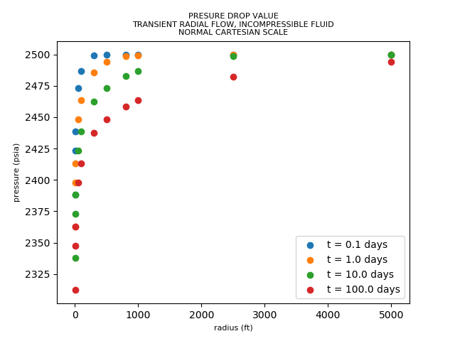
Gambar 1 Hasil plotting pressure terhadap radius dengan grafik normal
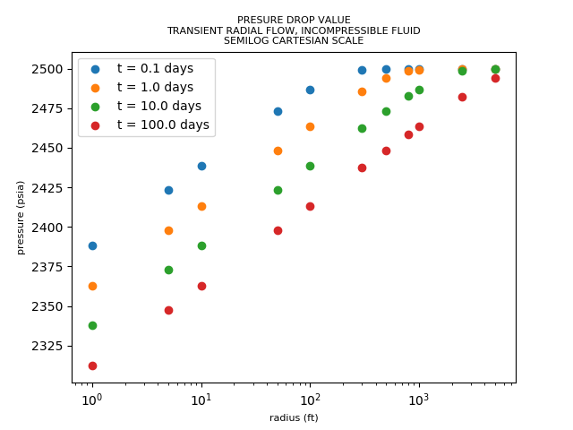
Gambar 2 Hasil plotting pressure terhadap radius dengan grafik semilog

